Day – 02 Task Report

Introduction:
This task focuses on identifying and handling missing values in the dataset to improve data quality. Various preprocessing techniques such as visualization, imputation, and removal of highly incomplete columns were applied. The dataset was then validated by comparing its size and quality before and after cleaning.
The Work:
In this task, the dataset (train.csv) was first loaded using the Pandas library. Missing values were identified and visualized using a bar plot created with Matplotlib to understand their distribution across features. Numerical columns were cleaned by imputing missing values with the median, while categorical columns were handled using mode imputation. Columns containing more than 40% missing values were removed to improve data quality. Finally, the dataset was validated by comparing its size and overall quality before and after the cleaning process.
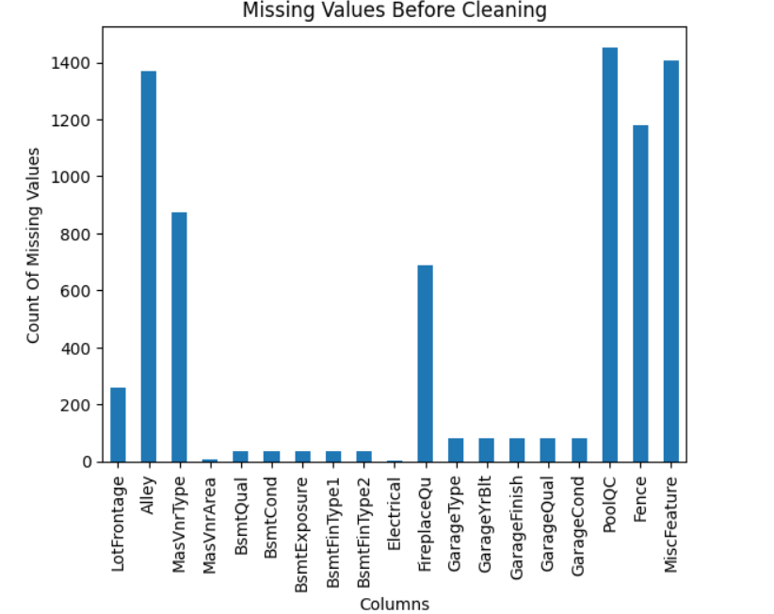
Fig:1. Visualization of the Missing Values Count Across Columns

Conclusion
The data cleaning process successfully addressed missing values using appropriate imputation techniques and column removal strategies. As a result, the dataset quality was significantly improved, with reduced inconsistencies and no remaining missing values. The cleaned dataset is now reliable and ready for further analysis or machine learning applications. Through this task, I learned how to perform essential preprocessing steps, including handling missing values in both numerical and categorical columns.

